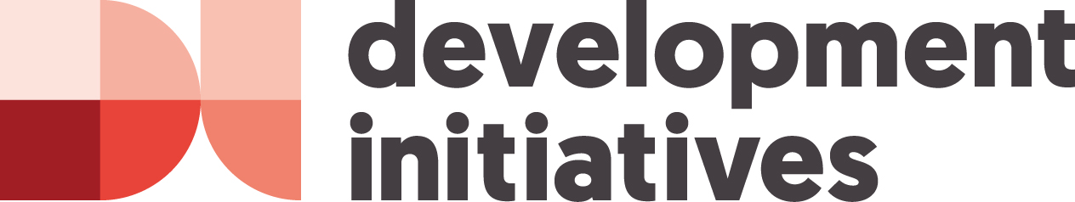

Key trends in humanitarian financing and next steps for the GHD:
A focus on multi-year funding, earmarking, localisation, cash and the humanitarian-development nexus

Friday 26 January 2018 0900-1030
Australian Mission, Chemin des Fins 2, Petit Sacconex

Objective

The objective of this roundtable is to
- better understand current trends in financing as relevant to particular GHD workstreams (including localization, multi-year funding, earmarking, cash and humanitarian-development nexus),
- build synergies between the financing aspects of these different work streams, and
- discuss how available resources can be better targeted through the different workstreams in order to address needs.

Agenda

0845-0900 Coffee and pastries

0900-0905 Opening remarks: (Catherine Gill, Humanitarian Counsellor Humanitarian)

0905-0930 Presentation: Sophia Swithern, Head of Research & Analysis, Development Initiatives

Presentation on current financing landscape with a focus on the five GHD work streams identified above, drawing upon key findings from the 2017 Global Humanitarian Assistance Report and additional analysis.

0930-1020 Discussion/Q&A session on GHD’s workstreams and issues raised

1020-1030 Closing remarks

Biography

Sophia Swithern, Head of Research and Analysis, Development Initiatives

Sophia is the head of Research and Analysis at Development Initiatives (DI). She also leads DI’s work on crisis response and resilience, including authoring four annual Global Humanitarian Assistance reports and speaking and writing widely on humanitarian financing. Before joining DI, she worked for Oxfam for over a decade - specialising in humanitarian protection, conflict transformation and forced migration including in DRC, Liberia and South Sudan. Prior to Oxfam she worked for UNHCR and for the UK’s Legal Aid Board. Sophia has a European Masters degree in Human Rights.

