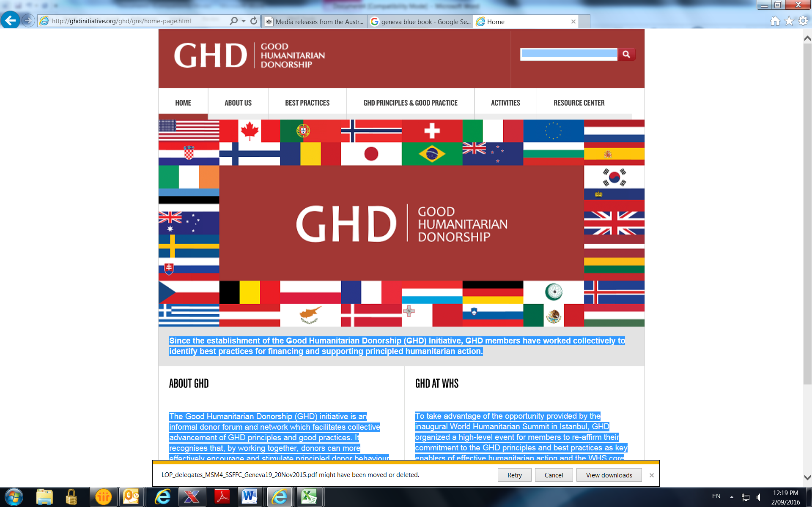

**Good Humanitarian Donorship Plenary Meeting**

**Wednesday 17 May 2017**

**10.00-11.30am**

**Venue: Australian Permanent Mission,**

**Chemin des Fins 2, Petit Saconnex**

**Agenda**

1. Welcome and opening remarks by Co-chairs
2. Work stream co-leads reporting to plenary on progress, activities and workshops
3. Update on High Level Meeting 19 June
4. One year after Istanbul: NGO Perspectives on progress from ICVA
5. Any other business/closing